

**Adapt IT Consulting and Training**

**ITS INTEGRATOR 4.1 – TRAINING MANUAL**

**Interface Manual**

Copyright

©All rights reserved

No part of this document may be reproduced or transmitted in any form or by any means, without express written permission from Adapt IT or an authorised representative of Adapt IT. This includes, but not limited to, electronic, electrostatic, magnetic tape or mechanical copying and recording, or use of any information storage and retrieval system.

First edition: February 2018

Disclaimer

Adapt IT makes no representations or warranties with respect to the contents hereof. Although due care and precaution has been taken in the preparation of this manual, Adapt IT assumes no responsibility for errors and omissions or any damages resulting from the use of the information contained in this publication .

**Contents**

Course Overview 1

**Layout** 1

**Module Structure** 2

1 System Access 3

1.1 Screen Resolution 3

2 Log in page 4

3 Integrator Entry Screen 7

3.1 Landing page 7

3.2 Navigation to a menu option 9

3.3 Adding Favourites 11

4 Accessing online help 12

5 Accessing the Work list and Batch process 13

5.1 Introduction 13

5.2 Running a batch program 13

6 Reports 15

6.1 Introduction 15

6.2 Jasper Reports 15

7 Forms 17

7.1 Introduction 17

7.2 Specific Rules Related to Forms Programs 18

7.3 Specific Rules Related to Forms Programs 19

8 Screen Patterns 20

8.1 Introduction 20

8.2 Entry Point (EP) 20

8.3 Simple Codes Table (TCS) 21

8.4 Table with Search Panel (TCM) 21

8.5 Multiple tables/Columns with Search Panel (TCL) 22

8.6 Search panel with results in query-only table (TQ) 24

8.7 Search panel with results in query-only tree table (TT) 24

8.8 Search Panel, Search Results Table with CRUD Form at the bottom(FCM) 25

8.9 Search Panel, Search Results Table (one or more) with pop-up CRUD Form (FCM-PC) 26

8.10 CRUD Form with Search pop-up or Search Panel (FCL) 27

8.11 Search Panel with Search Result Table and CRUD Form on different page (FCL-TSL) 27

8.12 Create only Form (FCO) 28

9 The Search Dialogue 29

9.1 Search Panel, Search Results Table with Form at the bottom 30

9.1.1 Search Panel 31

9.1.2 Results Table 32

9.2 Search Panel, Search Results Table, Form on different page 33

Acronyms, Glossary & Terminology 34

**Acronyms** 34

**Glossary** 35

**Terminology** 36

Need Help 38

**Course Overview**

ITS Integrator 4.1 user interface consists of Oracle forms and ADF task flows. ADF task flows are web based application that makes use of the Model View Controller architecture; this allows for different views of data to be presented, for example, in the form of web pages. The ADF modern technology guarantees our clients long-term benefits from their investment in the system. Our objective is to continuously improve the functionality of the Integrator system based on valuable feedback from clients, recommendations from industry experts and evidence from our research. The system has become more efficient and convenient due to the enriched web based functionalities. For example, the system will interface with more systems that provide functionalities outside the core ITS Integrator scope.

*iEnabler* products are also now accessible on mobile devices. System modules are continuously evaluated therefore irrelevant functional options were discontinued.

*This document gives a short overview of enhancements made to the Integrator interface.*

**Layout**

ITS Integrator 4.1 user interface consists of Oracle forms and ADF task flows. Existing users of the ITS Integrator system should be familiar with Oracle forms. ADF task flows are web based application that makes use of the Model View Controller architecture which allows for different views of data to be presented, such as web pages for humans, and web service interfaces for remote applications.

One of the biggest difference between forms and tasks flows are that forms contain the business logic opposed to task flows that contain little to no business logic. The business logic in the Model View Controller architecture is either carried on the web logic server or data base and promotes modularization and the reuse of code.

The main elements used in the Integrator 4.1 User Interface are:

* ADF Forms
* Tables
* Search areas.

These elements are used in combination or on their own depending on the specific Use Case, keeping usability and performance in mind.

**Module Structure**

Each module contains the following parts:

**Specific outcomes**

The specific outcomes are very important because they state what is expected of you.

**Introduction**

Each module starts with a statement of the content and learning outcomes for that module in order to introduce you to the subject matter of the module. Suggested time allocation is also indicated. Bear in mind that the time allocation is only a guide and some people will take longer than others to complete the same task. The timeframe can also be longer if you choose to look up content from other resources.

**Content**

Module content consists of information moving from system pre-requisites to operational and menu management issues. The content is subdivided into topics, tasks, procedures and other information arranged in a logical sequence and broken down into small, connected and understandable units. This content can be supplemented by support materials such as PowerPoint presentations, worksheets, hand-outs, etc.

**Acronyms, Glossary and Terminology**

As far as possible, the workbook uses clear and non-technical language. However, it is inevitable that you will be introduced to new terminology or be faced with the use of acronyms to describe or explain the contents of this manual. All terminology and/or acronyms used will be explained in the content, but you will also find separate structured tables at the end of this manual.

**MODULE**

**1**

# System Access

## Screen Resolution

Optimal screen resolution for Integrator is 1366 x 768 Pixels. 24 Inch or bigger monitors are highly recommended. Other resolutions for smaller monitors we recommend 1366 x 768 Pixels.

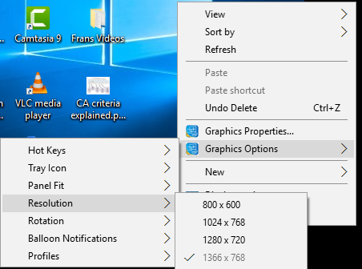

To set/change the screen resolution of a 24 Inch or bigger monitor on Windows XP / -NT or latest release:

1. Right-click anywhere on your Windows Desktop
2. Choose Properties (bottom of pop-up menu)
3. Click Settings Tab (last tab page)
4. Click and drag the bar at Screen Resolution to 1920 x 1080 Pixels
5. Click the OK button

**MODULE**

**2**

# Log in page

To access Integrator you need the use of Internet Explorer and Java 1.8 version 152 and higher (32 bit). Using your browser, use the URL relevant to your institution or link from the institutions’ local Intranet. You will be prompted for your user name and password. Username and passwords are set up in User Access Definitions {USERS-5} and maintained by the institution. A user can have multiple logins with the same user ID. It is dependent on institution rules and policies.

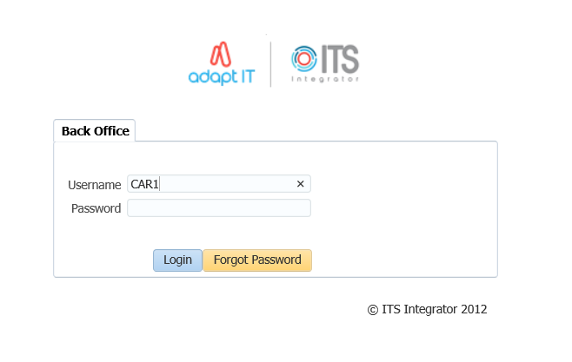

Once the login page has populated; enter your username and password. Select the ‘’login’’ button to gain access into the system.

After logging in, the Integrator Entry Screen will display.

**Forgot Password**

If you are having difficulty logging in to Back office or you forgot your password, you can reset your password.



1. Enter your Username
2. Click on the “Forgot Password” button

To be able to reset ITS/OID password, the users email address must be set up on {PBOP-14}/ {GOPS-3} and Primary Indicator for the email must be set to “Y”. If security questions are not set up on {USERS-17}, the user will get login control message to set up password questions and Answers.

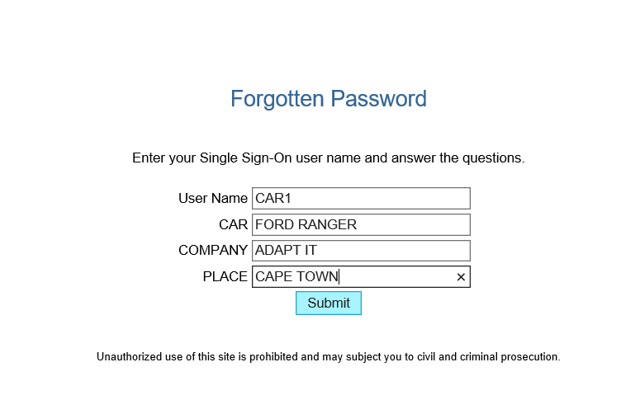

1. Answer the questions as set on {USERS-17}
2. click on “Submit button”

The notification pop up message to be illustrated

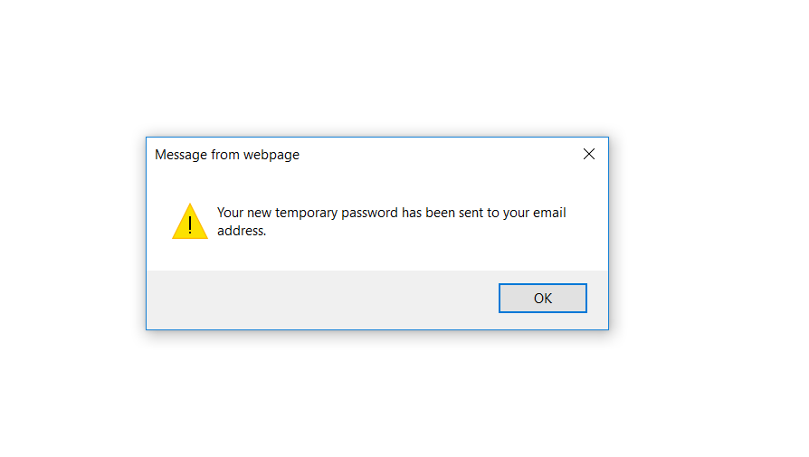

Logging in to ITS Integrator again with the given password on the email

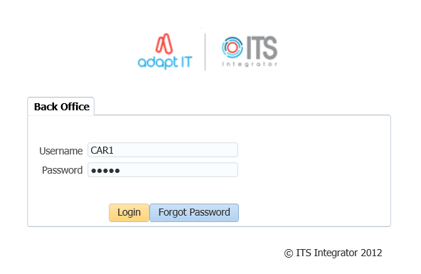

On the main page after logging onto integrator, on the More Tab, the Forgot Password Q and A can be found here and this will direct the user to {USERS-17}

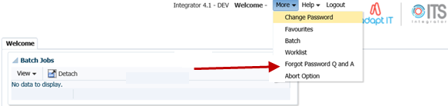

**MODULE**

**3**

# Integrator Entry Screen

## Landing page

After logging into the Integrator Back Office System the Integrator Entry Screen will display:

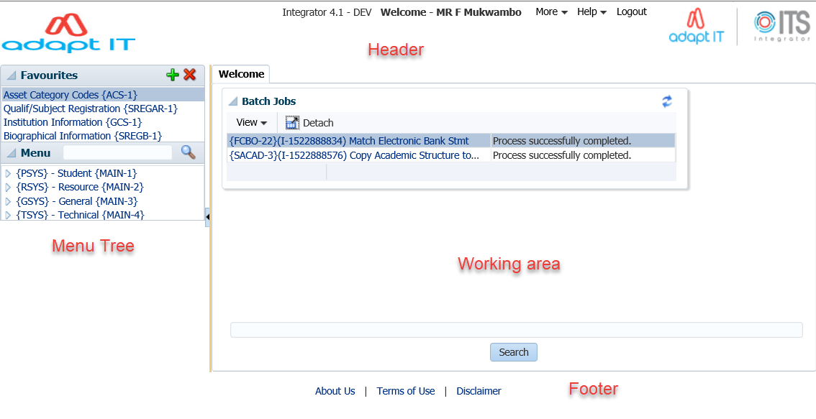

The Integrator Entry Screen is the gateway to the full ITS Integrator Back Office System as is made up of 4 sections: *Header, Main Menu Bar, Work Area, Welcome* and *Footer*.

| **Display** | **Where on Screen** | **Detail** |
| --- | --- | --- |
| **Header** | Top | This area contains the following:   * The Institution's Logo. This must be saved in the web/images directory as InsImg.jpg with dimensions of 125x56 * The user who logged in * "Home - Back Office" button which returns the user to the Integrator Entry Screen * "Logout" button which logs the user out of Integrator * "More" button which gives the user access to the following:   + Change Password   + Favourites   + Batch   + Worklist   + Abort * "Help" button which gives the user access to the following:   + Manuals - Gives the user access to the online Integrator help manuals   + Contacts - This will contain information for the person/department at the institution that is responsible for the Integrator system |
| **Main Menu Bar** | Left Side | The Main Menu Bar consists of two parts:   * Favourites - Will list all of the menus that the user has selected as favourites * Menu - Will allow the user to use the menu tree to get to the required menu. |
| **Welcome** | Middle & Right side | This part contains a search field that allow the user to search for the relevant menu that they require. The user can either search using the menu code and/or option, or for the name of the option |
| **Footer** | Bottom | This area contains the following links:   * Adapt IT Group. All Rights Reserved - Will redirect the user to an Adapt IT page * About Us -  The Institution can link this to their  home page * Terms of Use - The Institution can link their terms of use * Disclaimer - The Institution can link their disclaimer |

**Search:**

The searching of a menu/option now works differently to the forms based version of Integrator. The system will return all menus/options that contain the search criteria.

## Navigation to a menu option

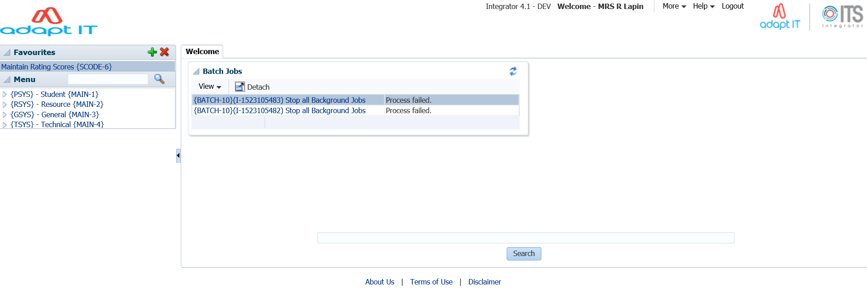

ITS Integrator 4.1 has two ways in which one can navigate to the menu options. The first can be seen on the main menu bar (left hand side) and the ‘’welcome’’ panel box.

Once the menu option has been inserted and the ‘’magnifying glass’’ selected; the menu search panel box will return all menus/options that contain the search criteria.

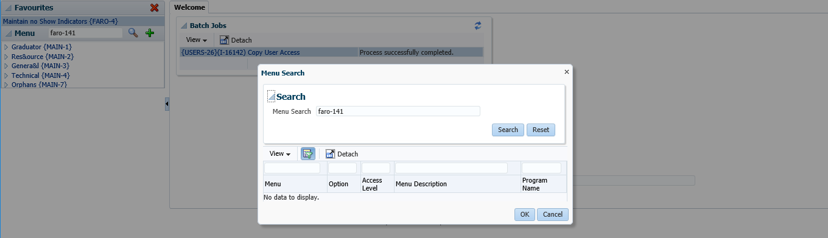

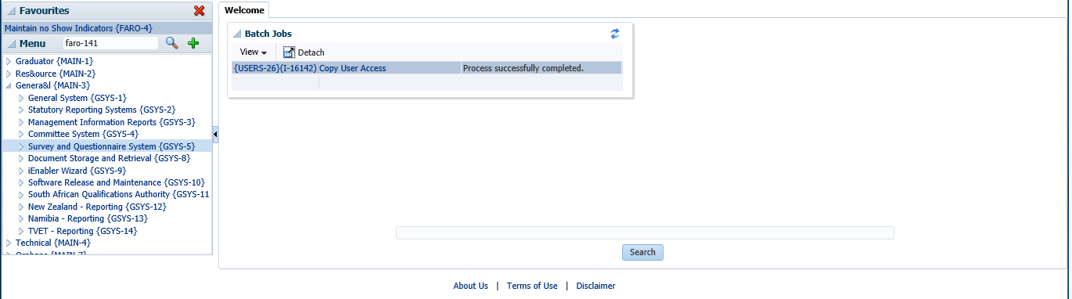

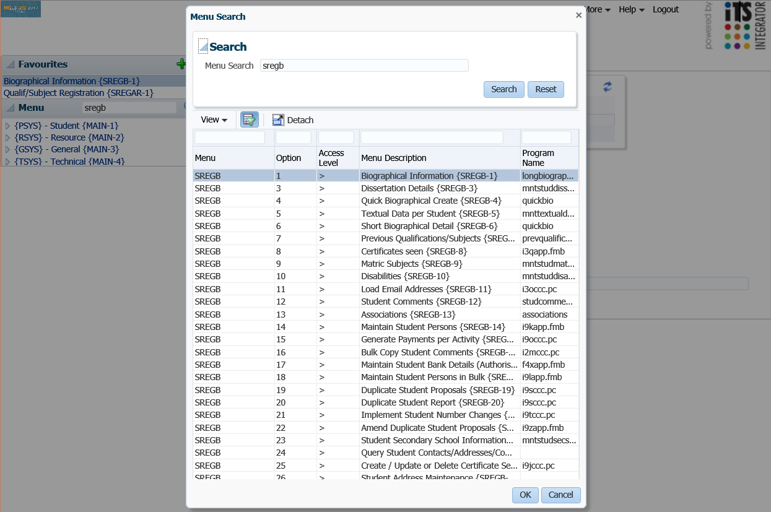

Alternatively, one can also use the tree search functionality to find the menu option desired



## Adding Favourites

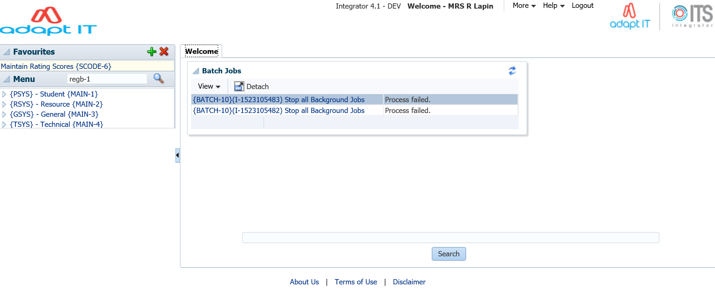

**2**

**3**

**1**

1. Open the desired menu
2. Click on the plus (+) button
3. Once this complete, the menu option will be added under the ‘’favourites’’ panel box

**MODULE**

**4**

# Accessing online help

On the Header; click on ‘’Help’’ and a dropdown with the options ‘’Manuals or About’’ will populate.

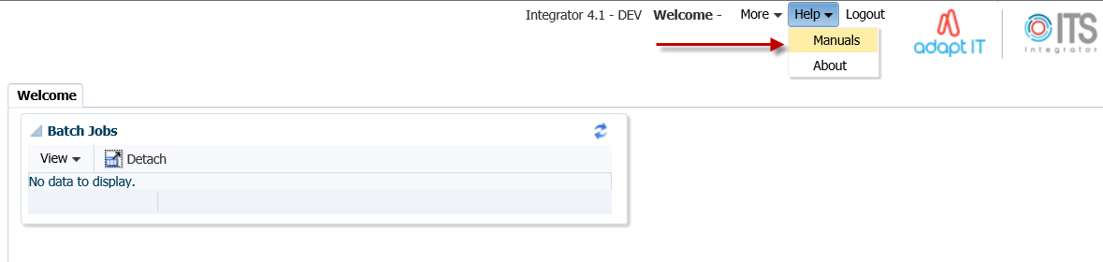

Select the Manuals option and the online help manual will display.

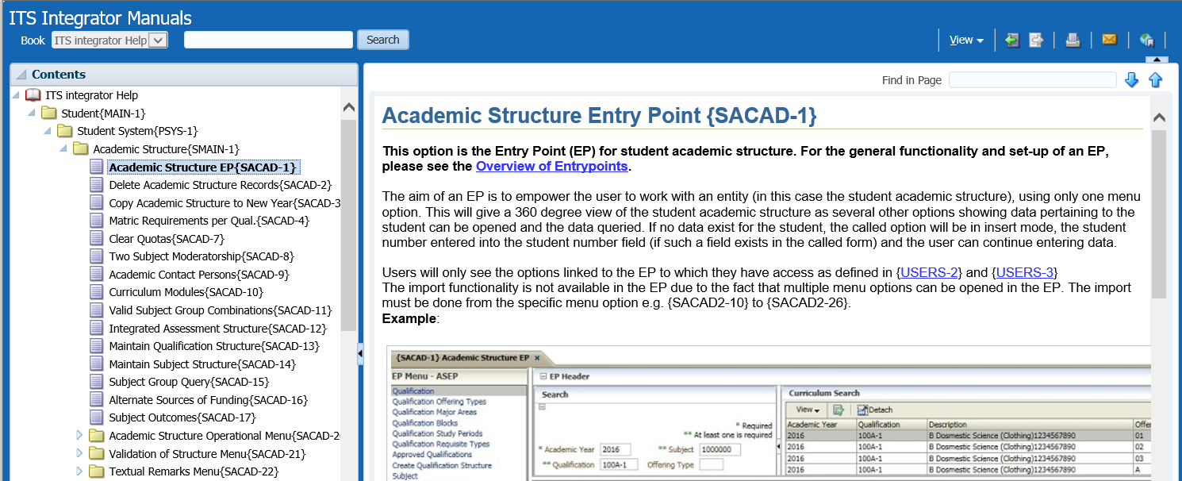

**MODULE**

**5**

# Accessing the Work list and Batch process

## Introduction

On the Header; the ‘’More’’ tab can be selected. Once selected a dropdown with the options ‘’change password, favourites, batch, work list and abort option’’ will populate. Select the batch or work list option.

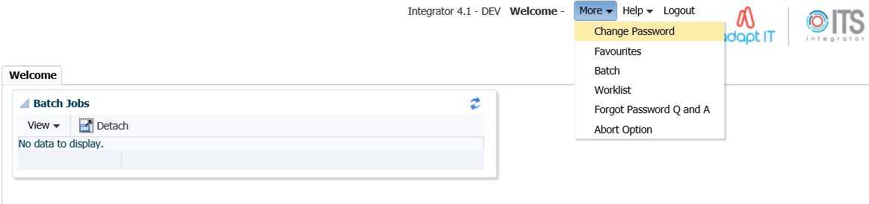

## Running a batch program

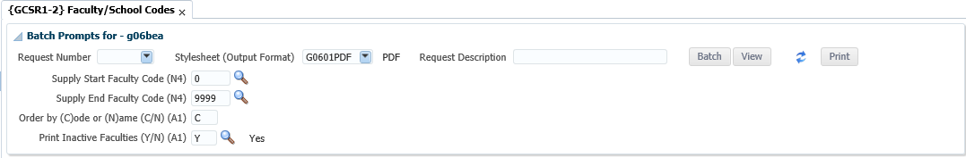

**3**

**2**

**1**

These are steps to follow when running a batch program report:

1. Select the output format
2. Press Tab to see more parameters and activate the batch butoon
3. Click on Batch

This is what the screen looks like once the report has run

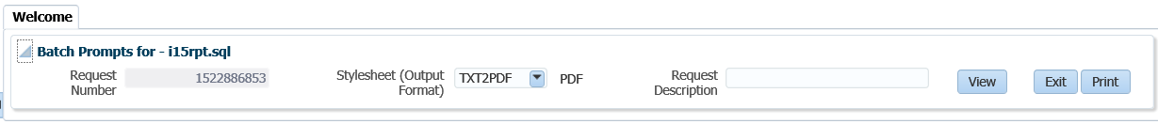

**1**

2\2

These are the steps to follow when running a batch program report:

1. Click on View to view the output in a browser tab
2. Click on Print to print through the system (unix)

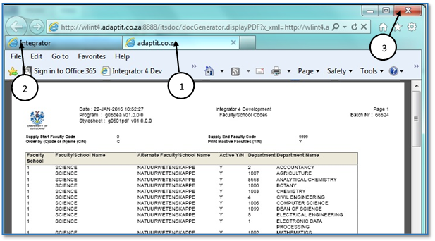

1. The output opens in a separate browser tab
2. Choose the original tab to navigate back to the system
3. Note: Do not close the Browser Window as it will close the whole session

**MODULE**

**6**

# Reports

## Introduction

The ITS Integrator 4.1 have been converted to Jasper which is a reporting and Business Intelligence tool.

## Jasper Reports

The infrastructure for the integration of Jasper reports is now in place on the Integrator 4.1 backoffice application.

* The first set of reports to be converted is based on the use of .RDF Technology
* Soft Transition
* Internal/External reports
  + Parameter display
  + Headings
* Report Formats

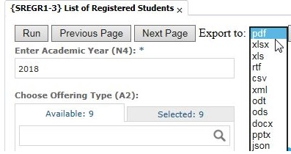

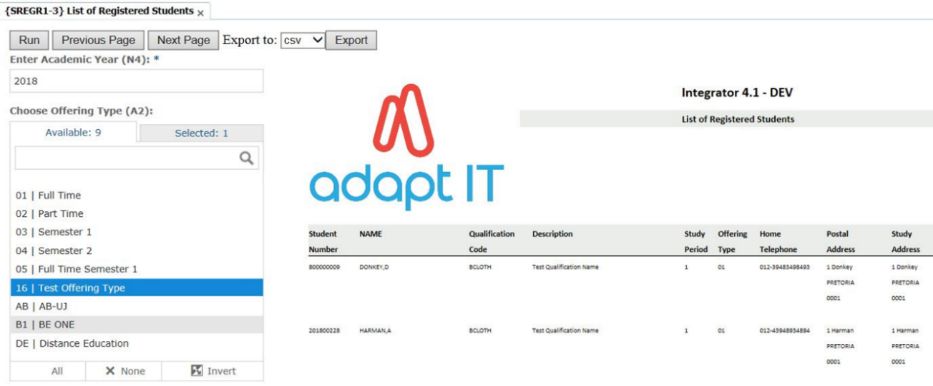

**MODULE**

**7**

# Forms

## Introduction

Some options still open Forms Programs and will be converted to the new ADF technology in the near future.

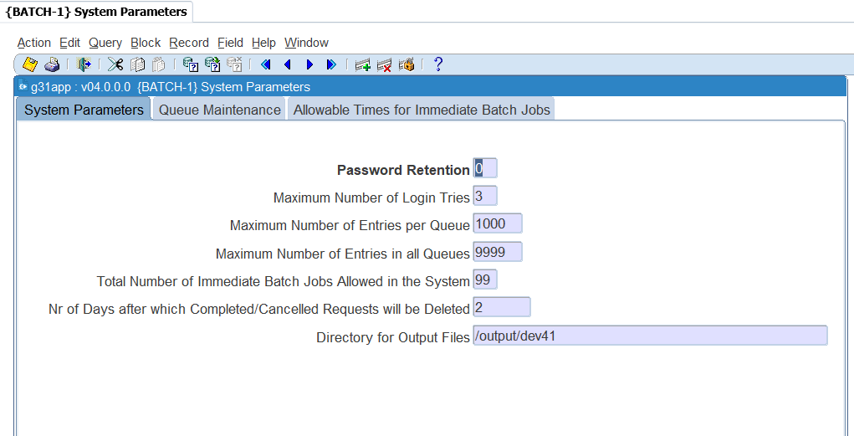

## Specific Rules Related to Forms Programs

1. Add the URL to run in Compatibility View

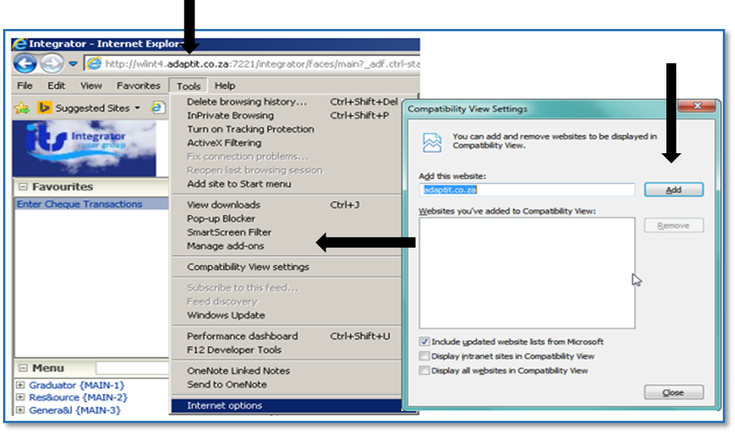

1. Add the Server to the Trusted Sites

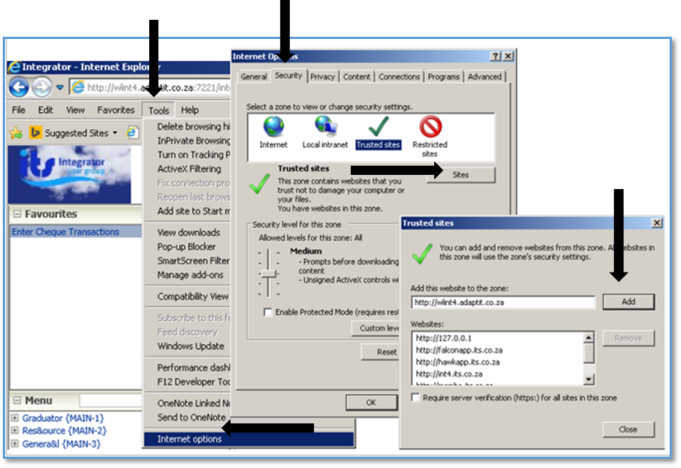

1. Select the Tools options 🡪 Internet Options 🡪Security 🡪 Trusted Sites 🡪 Sites 🡪 Entre URL 🡪 Add

## Specific Rules Related to Forms Programs



**2**

**1**

1. Always Exit using the “Exit” icon (Green Door iCon).

*Refrain from using the “Home – Back-Office” link in the header, unless the forms program does not open or is stuck due to Java 1.8 not being set-up correctly on the user’s PC or laptop.*

1. Always use the “Enter Query” icon.

**Please note:** The use of the F11 – key for “Enter Query” and other keystrokes is discouraged because browsers have their own ways of handling keys.

**MODULE**

**8**

# Screen Patterns

## Introduction

Different screen patterns are identified. The screen types used are based on the type of interaction and the number of records accessed.

## Entry Point (EP)

The aim of an EP is to empower the user to work with the Academic structure using only one menu option. This is described using the Academic Structure Entry point {SACAD-1} as an example. Users will only see the menu options linked to the EP to which they have access.

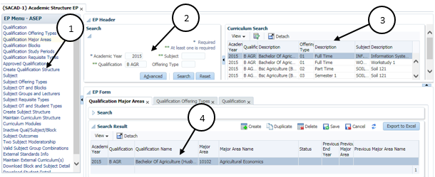

* 1. The EP Menu controls access to the individual options
  2. Search Panel for entry of Search criteria
  3. Search Results presented in table format
* The user should click on the “Detach” icon to see the complete information in table format without scrolling up and down as shown below
* Click on the “Detach” button to return back to previous Form.
  1. EP Form displays Qualification/Subject with focus as per selected EP control

## Simple Codes Table (TCS)

Simple codes table without a Search Panel, E.g. Work/Shift Patterns {COOPC-27}.

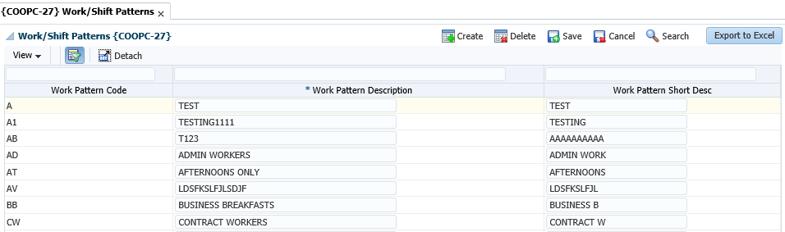

1. Create button can be used to create a new record and the empty row will display.
2. Data is presented in an updatable table format.
3. The User can click on the “Detach” icon for better view of data
4. Export to Excel button

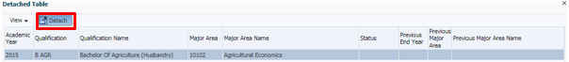

* Always allows Read (Query) and at least one of Create, Update or Delete operation
* Information is queried automatically
* Record level validations only, or, simple field level validations
* No cross-field dependencies
* Low volume of records and < 10 fields

## Table with Search Panel (TCM)

Simple table with a Search Panel, for small to medium size CRUD, e.g. Certificates Seen {SREGB-8}

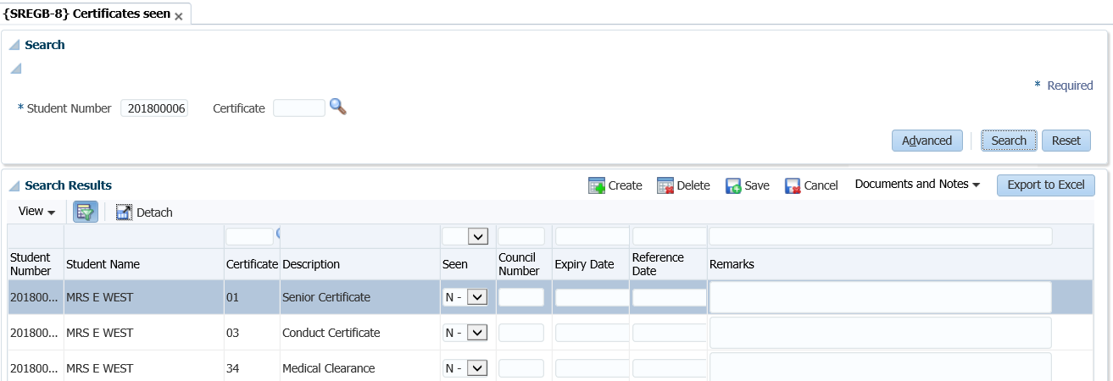

* Always allows Read (Query) and at least one of Create, Update or Delete operation
* No automatic querying
* Possible cross-field dependencies and complex validations
* Less than 30 fields

## Multiple tables/Columns with Search Panel (TCL)

CRUD Table (one or more) with collapsible column groups or column hiding and Search Panel for Large size CRUD e.g. Curriculum {SACADO-17}

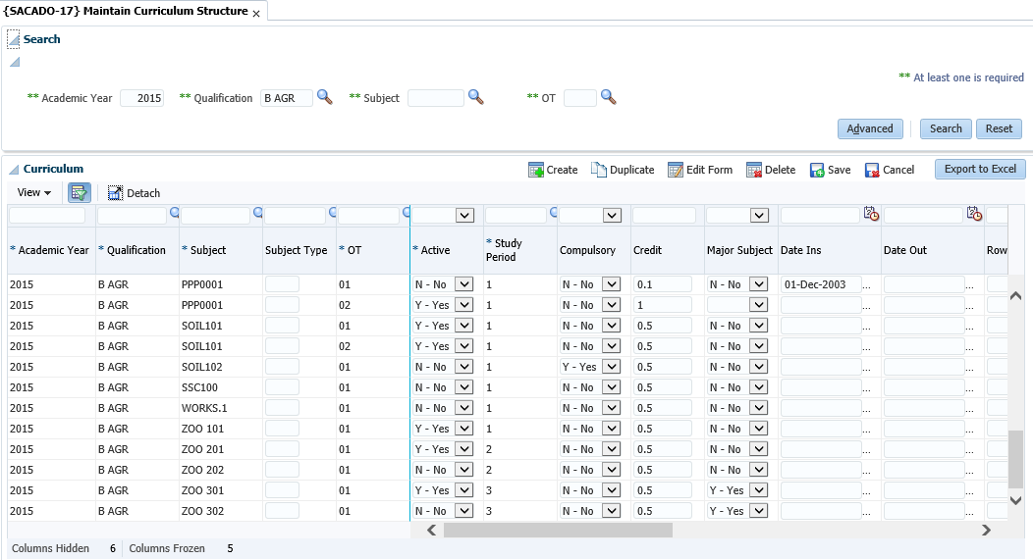

1. Search Panel where the user can type in the query criteria
2. Search Results is displayed in the table format
3. Export to Excel button
4. The information on the table can be detached for better viewing of the information presented in the table format
5. Duplicate existing record.

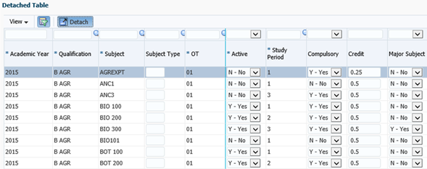

* Always allows Read (Query) and at least one of Create, Update or Delete operation
* No automatic querying
* Possible cross-field dependencies and complex validations
* More than 30 columns.

## Search panel with results in query-only table (TQ)

Query-only e.g. Query Student Account {FSAO-7}

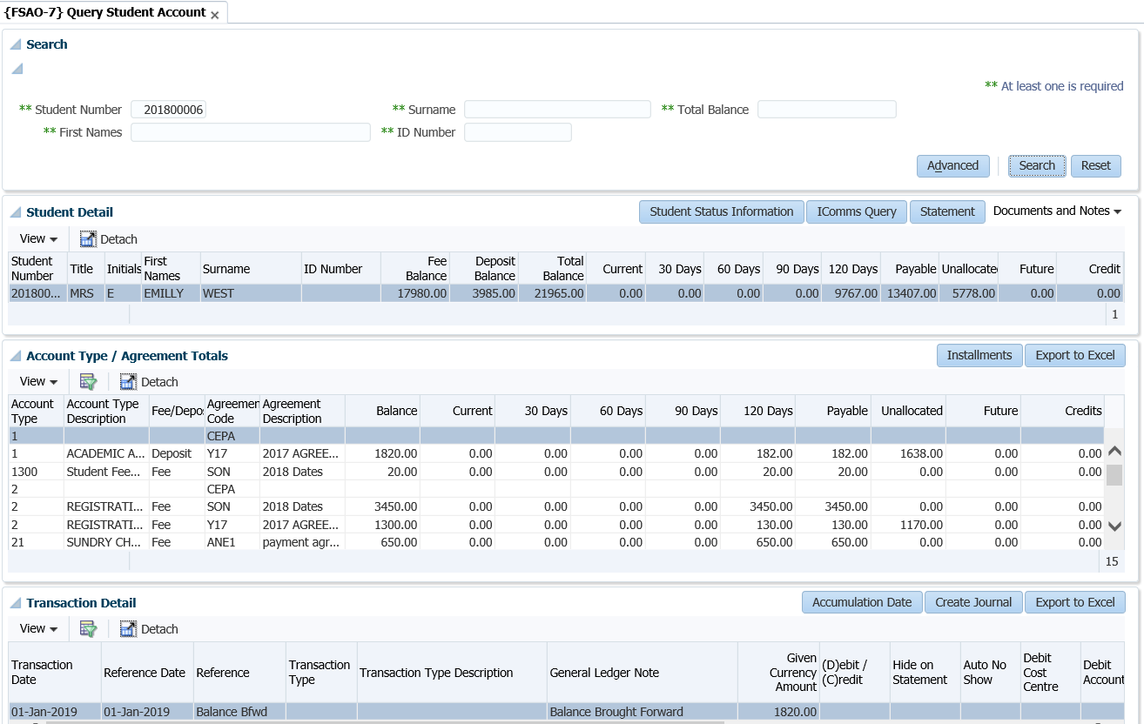

* Always allows Read (Query) and at least one of Create, Update or Delete operation
* No automatic querying
* Possible cross-field dependencies and complex validations
* Less than 30 Columns in table

## Search panel with results in query-only tree table (TT)

Query-only e.g. Revenue Expense Query {FGLO-10}

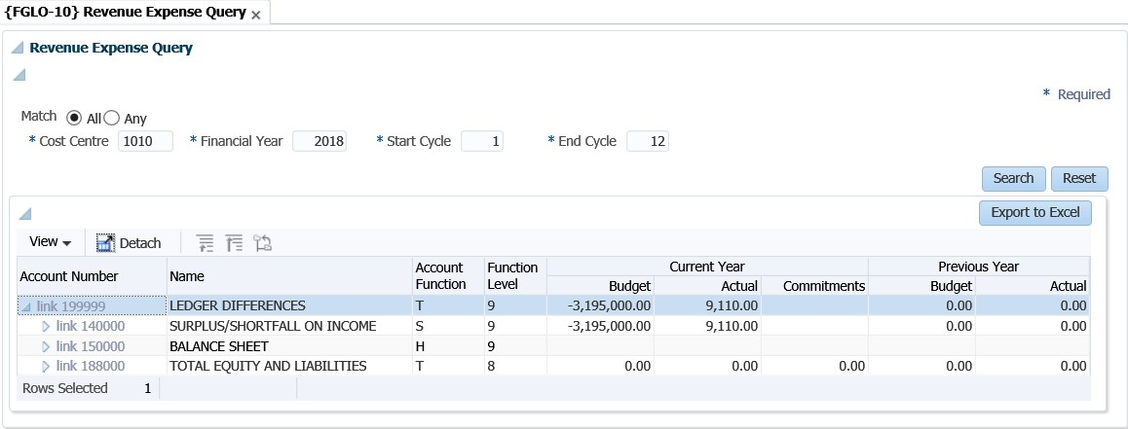

## Search Panel, Search Results Table with CRUD Form at the bottom(FCM)

Small to medium size CRUD e.g. Curriculum {PBOP-8}

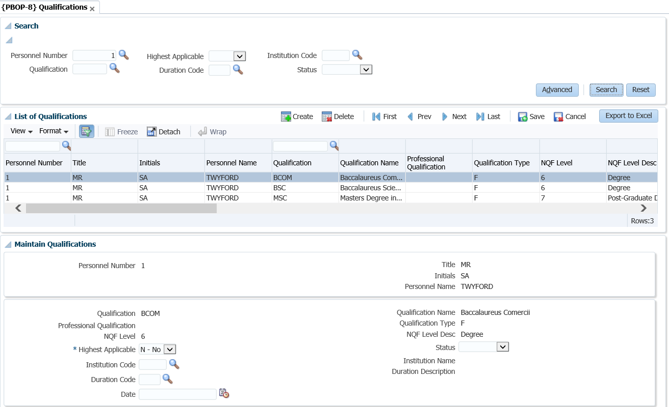

* Always allows Read (Query) and at least one of Create, Update or Delete operation
* No automatic querying
* Possible cross-field dependencies and complex validations
* Less than 30 Columns in table

## Search Panel, Search Results Table (one or more) with pop-up CRUD Form (FCM-PC)

Small to medium size CRUD e.g. Query Student Account {FSAO-7}.

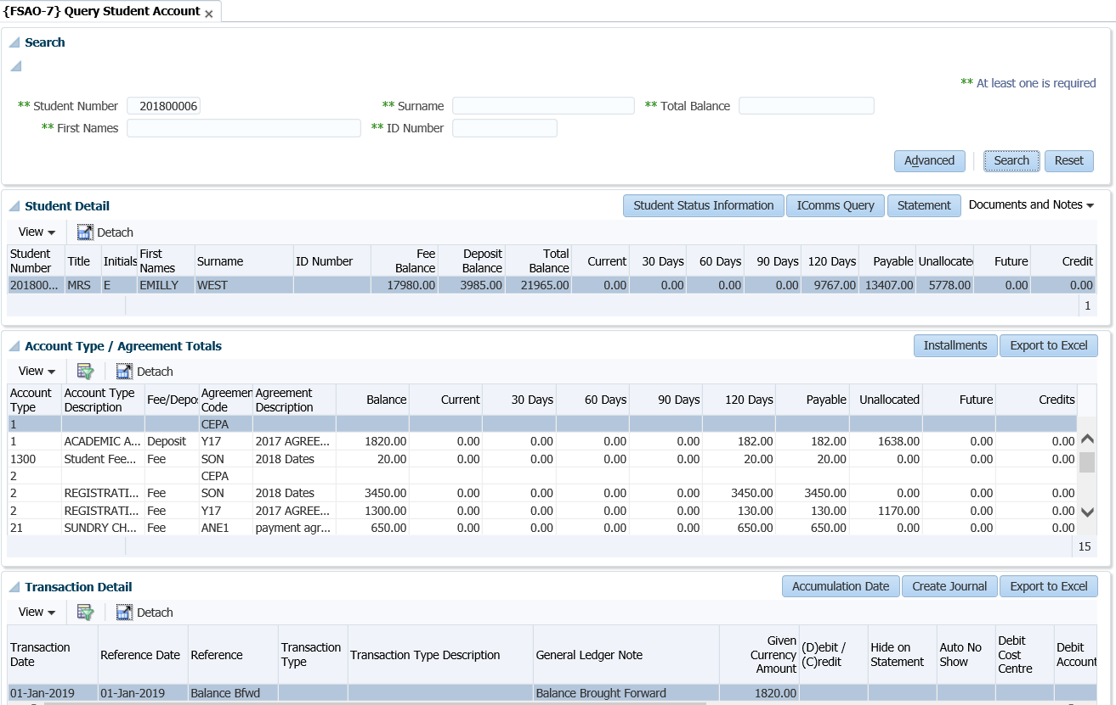

* Always allows Read (Query) and at least one of Create, Update or Delete operation
* No automatic querying
* Possible cross-field dependencies and complex validations
* Less than 30 Columns in table

## CRUD Form with Search pop-up or Search Panel (FCL)

Large size CRUD e.g. Query Student Account {FSAO-1} or Define and Maintain Subject {SACADO-10}.

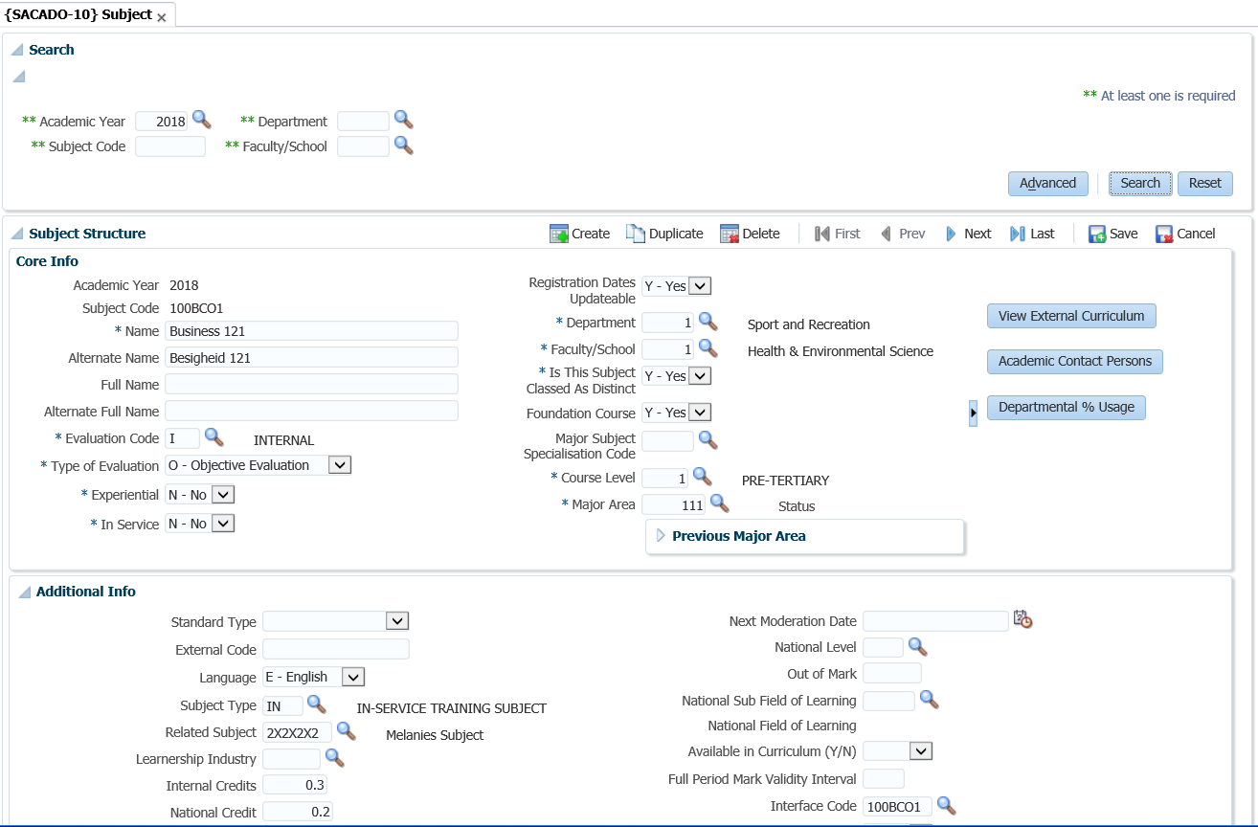

* Always allows Read (Query) and at least one of Create, Update or Delete operation
* No automatic querying
* Possible cross-field dependencies and complex validations
* More than 30 Columns in table

## Search Panel with Search Result Table and CRUD Form on different page (FCL-TSL)

Large size CRUD e.g. Post Establishment {PPEO-1}.

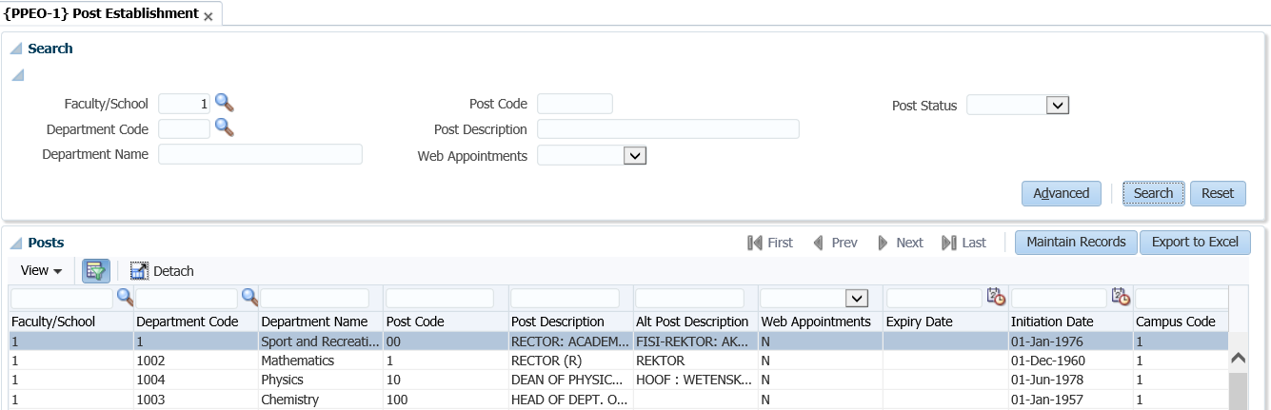

* Always allows Read (Query) and at least one of Create, Update or Delete operation
* No automatic querying
* Possible cross-field dependencies and complex validations
* More than 30 Columns in table

## Create only Form (FCO)

Create-Only e.g. Bank Statement Reconciliation {FCBO-4}

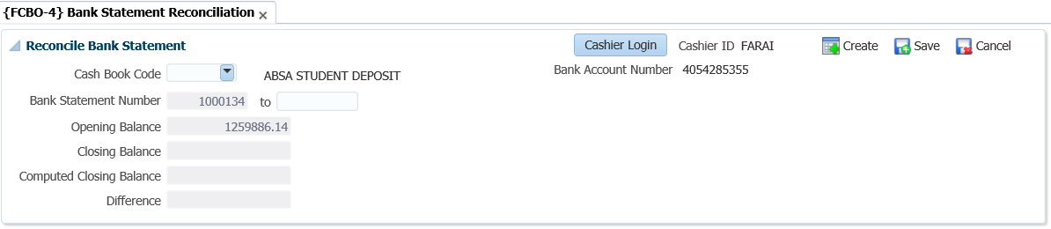

**MODULE**

**9**

# The Search Dialogue

To search; select the ‘search’ option on the right hand side of the screen. Once selected, the ‘Search dialog’ box will populate. Various search criteria’s can be supplied to access the data desired.

An advanced search option is also available.

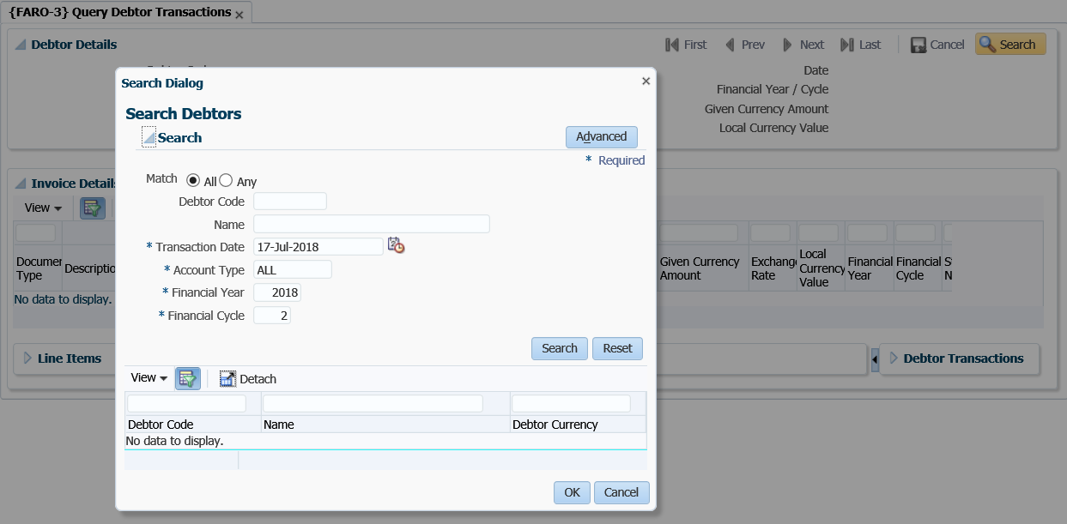

Once the advance search option has been selected; a number of search fields will populate. On the list of fields available, you can choose the field applicable to your Institute or department filter, for future searches.

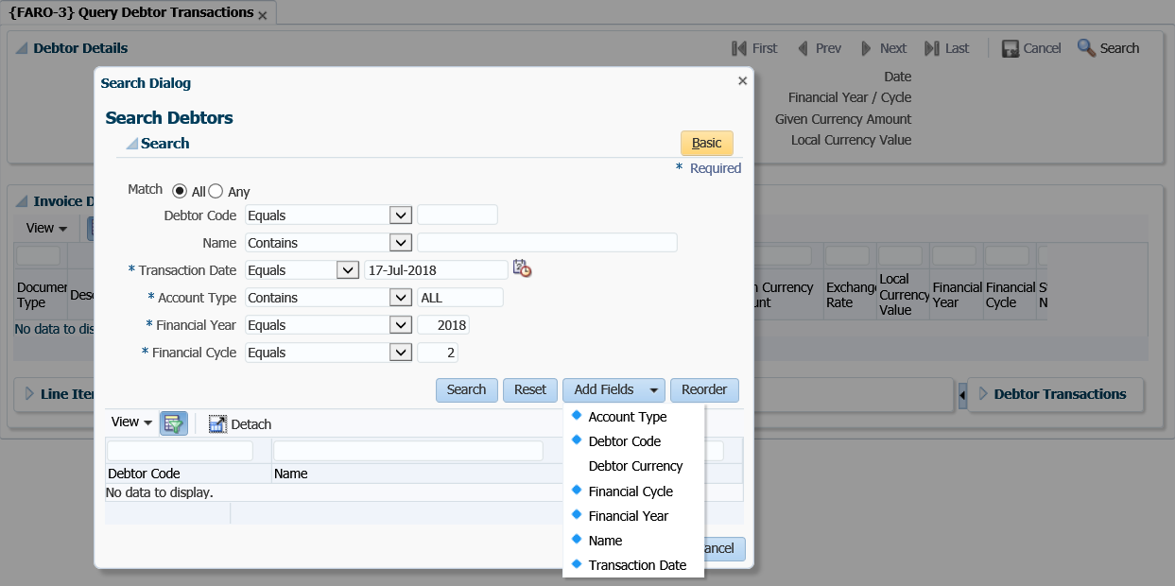

## Search Panel, Search Results Table with Form at the bottom

Each menu has got different panel boxes available on one page. Most Panel boxes comprise of the Search panel, the Search results panel and the forms at the bottom of the page.

Qualifications {PBOP-8}

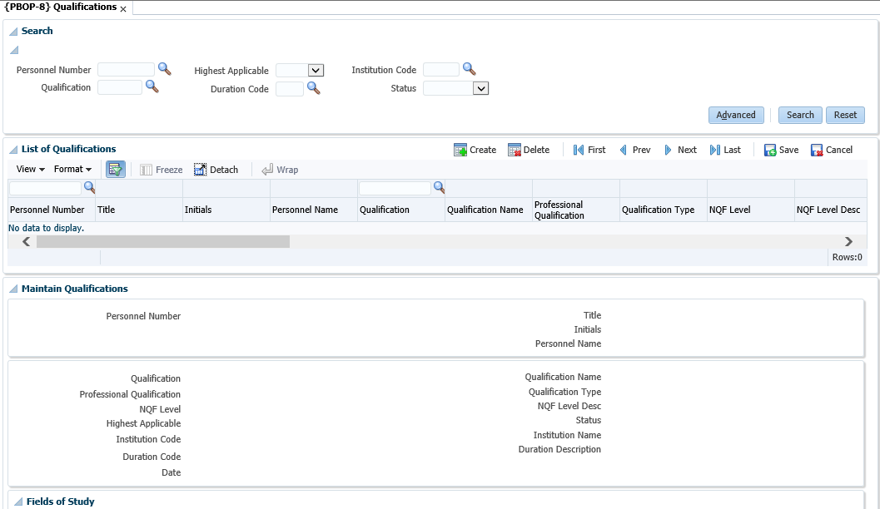



Maintenance Form

Results Table

Search Panel

### Search Panel

Fields that appear here are only used to “Search”, in other words, they are “Query Criteria”.

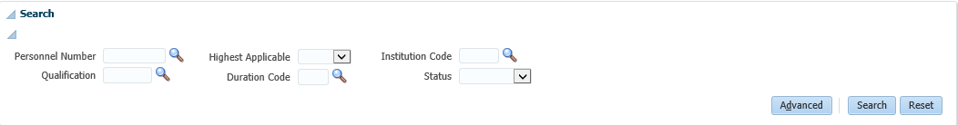

**Search** will search the database for records that match the “Search – Criteria” and display them in the Results Table. Clicking Search when all the fields in the Search Panel is blank (or null), will return all records, otherwise only those that match the fields in the Search Panel. It can be closed by clicking on the Disclose / Close icon

**Advanced** allows the user to “Search” in an advanced way and/or to add fields to the Search Panel

**Reset** will only make the value fields in the Search Panel blank (or empty or null), it will not clear the Results Table or the Form at the bottom.

### Results Table

In this User Interface Pattern, data in the Results Table cannot be updated. The record selected here will be available in the Form for update purposes

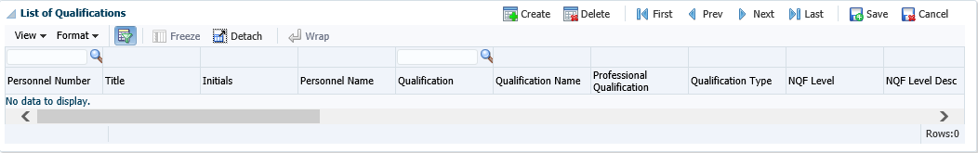

**Delete** will delete the selected record (It only becomes effective in the database after clicking Save)

**Create** will create a new record with blank fields. (It will be available in the Form to complete and it only created in the database after clicking Save)

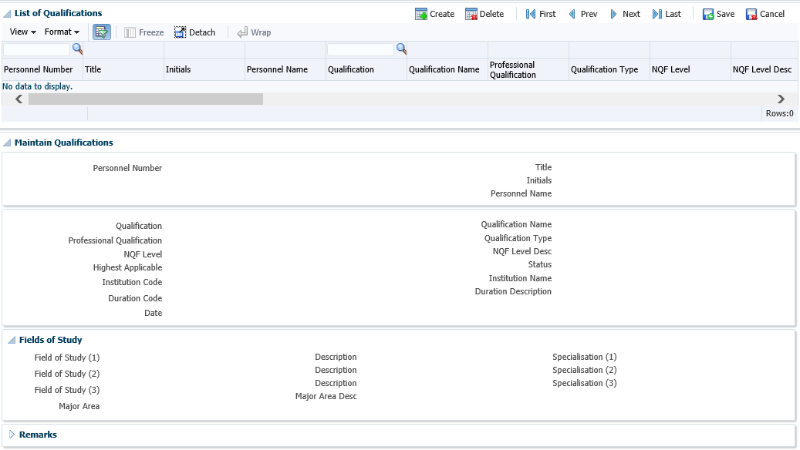

**3**

**2**

1

1. Menu Bar above the Results Table
2. Close / Disclose icon to hide or open Panel Box
3. Combo Box List

## Search Panel, Search Results Table, Form on different page

Post Establishment {PPEO-1}

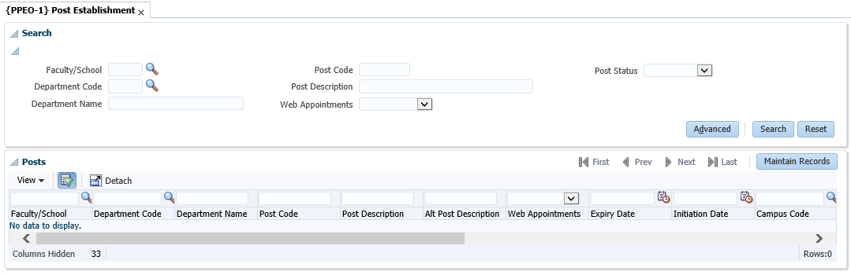

**1**

1. The same as the previous pattern, but use Toolbar Buttons to navigate between the Search Panel / Search Results and the Maintenance Form

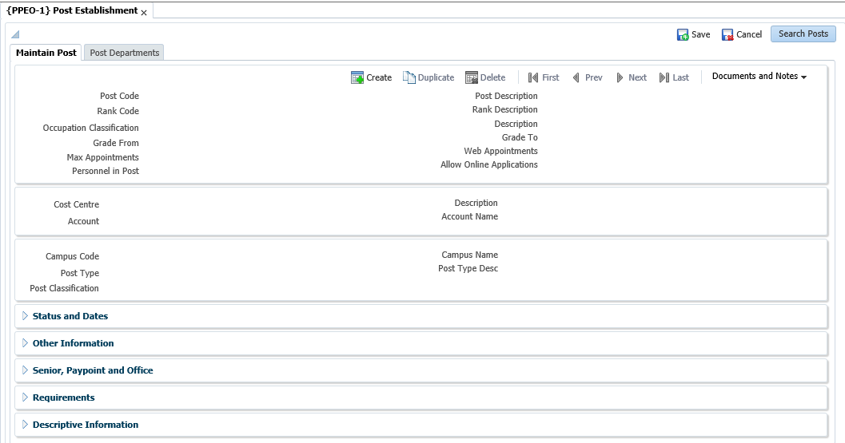

**2**

**1**

1. Navigation back to Search Panel and Results Table
2. These Panel Boxes are closed by default and can be disclosed using the Close / Disclose Buttons

**Acronyms, Glossary & Terminology**

**Acronyms**

|  |  |
| --- | --- |
| **Acronym** | **Definition** |
| **DSL** | Data Sheet Layout (spreadsheet format of selected applications) |
| **DSR** | Document Storage and Retrieval |
| **EP** | Entry Point |
| **ES** | Entry Screen (menu/front end) |
| **iComms** | I-Communications - New Implementation of Selected Letters, Lists and Labels via Desktop Integration. I.e. Creating Letters with a Word Processing Application outside the ITS Back -Office System. |
| **iGrams** | A Visual Representation of Complex Data for Simplification. |
| **LOV** | List of Values |
| **OID** | Oracle Internet Directory |
| **PCL** | Printer Controlled Language |
| **PoE** | Portfolio of Evidence |
| **SMS** | Student Management System |
| **SSO** | Single Sign On |
| **URL** | Uniform Resource Locator. Usually pronounced by sounding out each letter but, in some quarters, pronounced "Earl" - is the unique address for a file that is accessible on the Internet. |
| **XML** | Extensible Mark-up Language. A mark-up language like HTML, used in reporting and iComms |
| **XSL** | Extensible Style sheet Language. A style sheet defining the output format of XML |

**Glossary**

|  |  |
| --- | --- |
| **Term** | **Definition** |
| **Block** | A section of screen that displays related information associated with a record. |
| **Canvas** | Any ‘white space’ on a screen. Right-clicking on the canvas usually offers additional options. |
| **Database** | An electronic system of storing and retrieving information so that it can be displayed according to a number of predetermined formats. |
| **Execute query** | The act of conveying search criteria to retrieve and display selected data. |
| **Field** | A box on the screen that displays numeric or alphanumeric information, or permits numeric or alphanumeric information to be entered. |
| **List of Values** | A list of codes (numeric or alphanumeric) accessible through menus in certain fields.  **Note:** Is represented by an ellipsis or  at the end of the field. |
| **Output** | The displayed or printed result by which information is requested from the database through a query or entered search criteria. |
| **Query** | A database term for a search carried on one or more fields on a screen. |
| **Query criteria** | Search criteria used in a query. |
| **Record** | A data structure composed of one or more fields. |
| **Report** | The displayed or printed output resulting from report criteria used to generate a report. |
| **Report query** | Criteria used to search the database so that a report is generated. |
| **CRUD** | Create/Read/Update/Delete operations. |
| **MPM** | Multi-Processing Module |
| **Panel Boxes** | A Panel Box is used to place ancillary information on a page, offset by a certain colour / border. |
| **UI** | User Interface |

**Terminology**

|  |  |
| --- | --- |
| **Term** | **Definition** |
| **Academic structure** | This is the structure of all academic qualifications / study programs offered by a university, linked to a faculty, then to an academic department, and then linking all the subjects / courses / modules that form part of the curriculum to the qualification / program. It includes all pre- and co-requisites per subject / course, credits per subject / course / module, formats of offering and all relevant information related to the completion of a particular qualification, i.e. degree, diploma, etc. This structure is maintained on the university’s student information system. |
| **Analyze** | Interpretation  Apply of processes  Examine, Investigate, Consider, Evaluate or Scrutinizes |
| **Block** | A section of screen that displays related information associated with a record. |
| **Calculate** | Compute |
| **Canvas** | Any ‘white space’ on a screen. Right-clicking on the canvas usually offers additional options. |
| **Compile** | Collect, Assemble, Accumulate or Gather |
| **Copy** | Duplicate |
| **Database** | An electronic system of storing and retrieving information so that it can be displayed according to a number of predetermined formats. |
| **Dean** | The person who has been appointed by the university as the academic head of a faculty. |
| **Department** | A sub-section of a faculty’s organizational structure, based on an academic field and / or main subject, whereas the particular department is responsible for the qualifications or study programs that are linked to the field or main subject. An academic department is headed up by a Head of Department (HOD). |
| **Execute query** | The act of conveying search criteria to retrieve and display selected data. |
| **Faculty** | A sub-section of a university’s academic structure, based on a collective but related number of study fields or subjects, e.g. Faculty of Medicine. A faculty is headed up by a Dean. |
| **Faculty Administrator** | The person who has been appointed to execute the administrative functions of a faculty that includes inter alia student administration, financial administration and committee administration. |
| **Faculty Manager** | The person who has been appointed to manage the overall administrative functions of a faculty, and who is a member of the faculty’s executive management team. |
| **Field** | A box on the screen that displays numeric or alphanumeric information, or permits numeric or alphanumeric information to be entered. |
| **Generate** | Create or Delete Data  Compute Results  Adjust Results  Print or Run a Report  Print or Run a List  Print or Run a Letter  Print or Run a Label  Print or Run a Log File |
| **HOD** | The person who is appointed as the head of an academic department. |
| **List of Values** | A list of codes (numeric or alphanumeric) accessible through menus in certain fields.  **Note:** Is represented by an ellipsis or  at the end of the field. |
| **Maintain** | Create, Capture, Insert or Enter Records  Delete, Purge Records  Update, Change or Rectify Records |
| **Output** | The displayed or printed result by which information is requested from the database through a query or entered search criteria. |
| **Query** | A database term for a search carried on one or more fields on a screen. |
| **Query criteria** | Search criteria used in a query. |
| **Record** | A data structure composed of one or more fields. |
| **Report** | The displayed or printed output resulting from report criteria used to generate a report. |
| **Report query** | Criteria used to search the database so that a report is generated. |
| **Rollback** | Reversal |
| **Screen** | All that relates to data can be displayed or entered in fields in one or more blocks. |
| **Utilize** | Query, View, Understand or Use Information |
| **Verify** | Check, Control, Confirm or Validate Information |

# Need Help

You can refer to our online help manual available on the system or alternatively contact the Adapt IT – Consulting and Training team.

**Physical Address**

152 14th Rd

Noordwyk

Midrand, 1687

Johannesburg

South Africa

**Tel**: +27 (10) 494 0000

**Email**: [EDU.consulting@adaptit.co.za](mailto:EDU.consulting@adaptit.co.za)

**Website**: [www.adaptit.co.za](http://www.adaptit.co.za)